**Lab Assignments**

**Data Communication and Networks**



Submitted by: Submitted to:

Ajay Singh Dr. Vishakha Chourasia

(20U03058) (Professor)

Indian Institute of Information Technology, Bhopal

**Department of Information Technology**

Data Communiction and Network (IT-311)

Bachelor of Technology

3rd Year, 5th Semster

**Index: Table of Content**

|  |  |  |  |  |
| --- | --- | --- | --- | --- |
| S.No | Assignment Name | Performance Date | Submission Date | Page No |
| 1. | Know the Basics of Cisco Packet Tracer.  Download and work with CPT. | 27/07/2022 | 27/07/2022 | 1 |
| 2. | Establish pair to pair communication and show that delivery of packets is successful check MAC and PHY address of systems. | 03/08/2022 | 03/08/2022 | 11 |
| 3. | Simulate LAN using HUB after setting show packet movement through simulation. | 03/08/2022 | 03/08/2022 | 12 |
| 4. | Demonstrate the use of the switch and show through stimulation the working of the same. | 10/08/2022 | 10/08/2022 | 14 |
| 5. | Demonstrate static routing with the use of the router to establish communication between two different LANs. | 10/08/2022 | 10/08/2022 | 16 |
| 6. | Demonstrate Dynamic routing with the use of the router to establish communication between two different LANs. | 17/08/2022 | 17/08/2022 | 18 |
|  |  |  |  |  |
|  |  |  |  |  |

**ASSIGNMENT – 01**

1. **Know the Basics of Cisco Packet Tracer.**
2. **Download and work with CPT.**

**Solution:**

**Cisco Packet Tracer:**

**Introduction –**

* The leaders in Networking.
* It is a cross-platform visual simulation tool designed by Cisco System that allows users to create network topologies and imitate modern computer networks.
* The software allows users to simulate the configuration of Cisco routers and switches using a simulated command line interface.
* Platforms: Windows, Linux, Android, MacOS.
* An innovative and powerful networking simulation tool used for practice, discovery and, troubleshooting.
* Helps to understand network practically.

**How To Download Cisco Packet Tracer…**

***Step 1 –***

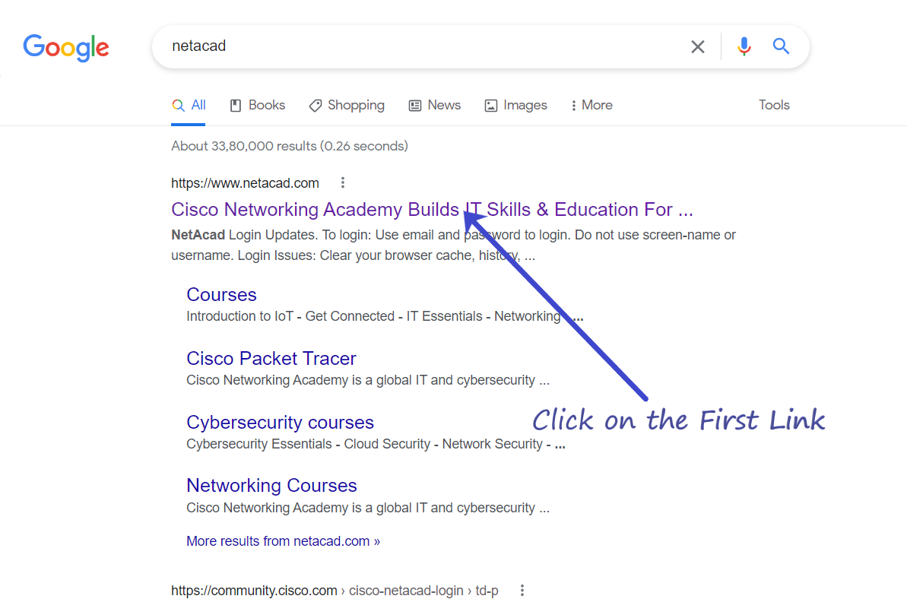

***Step 2 –***



***Step 3 –***

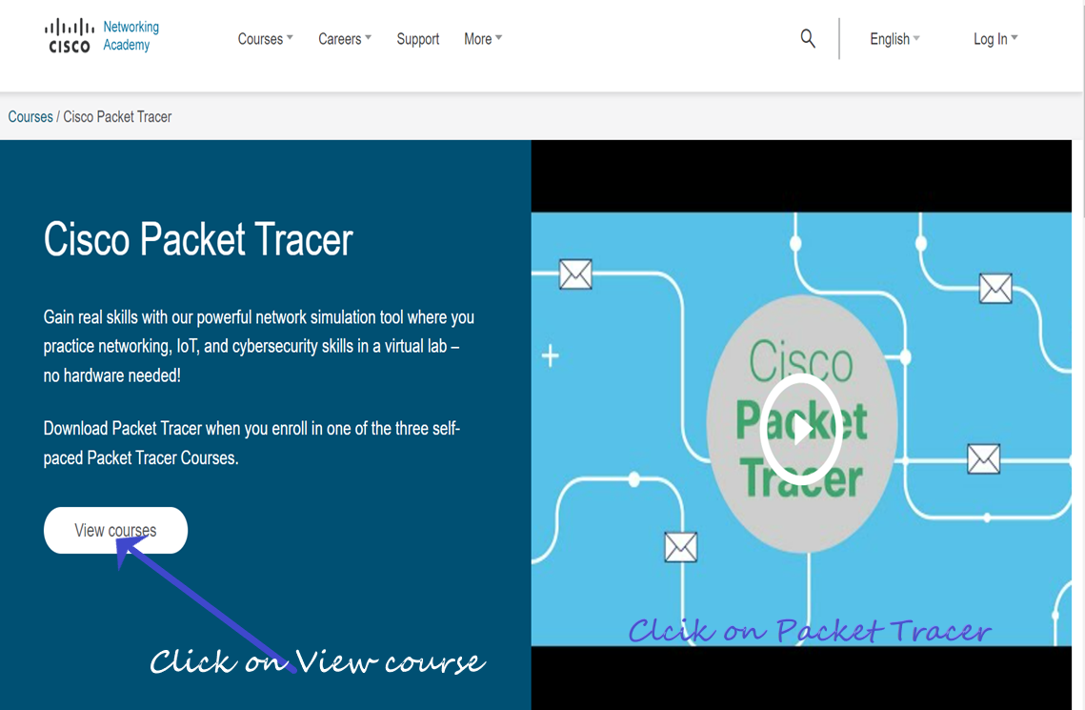

***Step 4 –***



***Step 5 –***

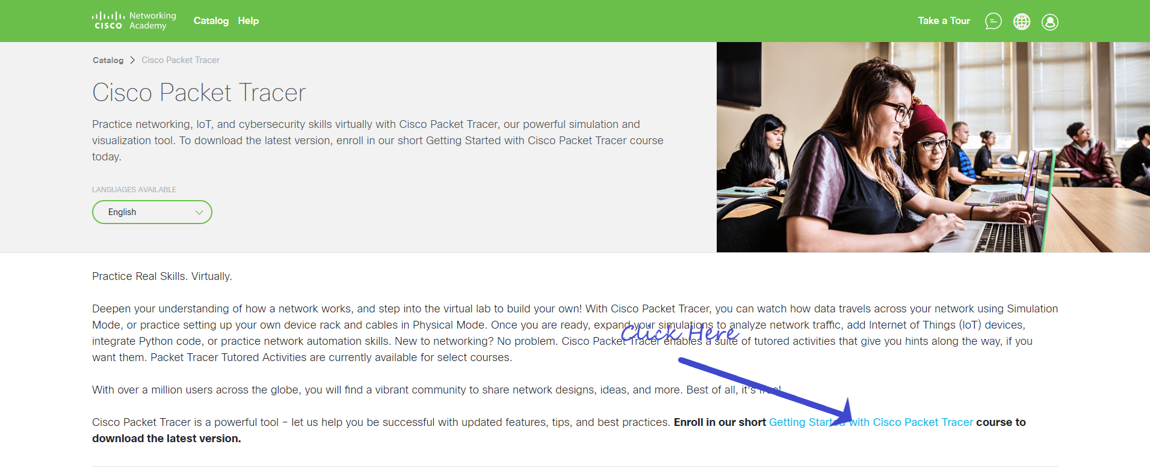

***Step 7-***

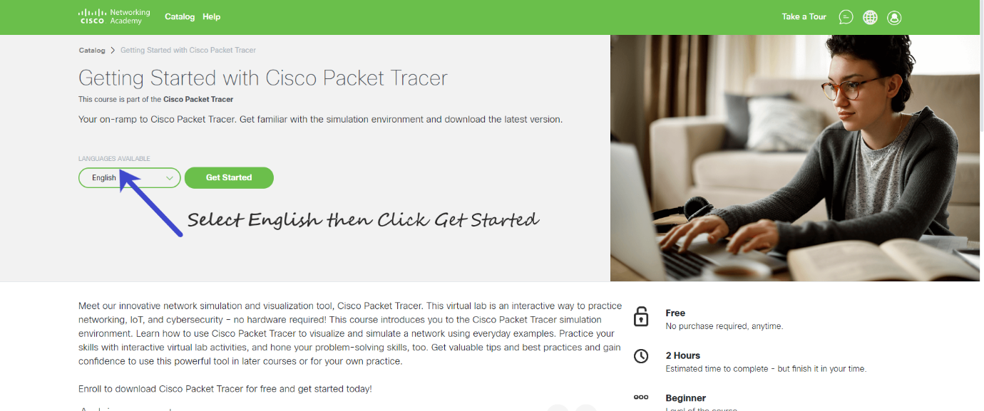

***Step 8 –***



***Step 9 –***

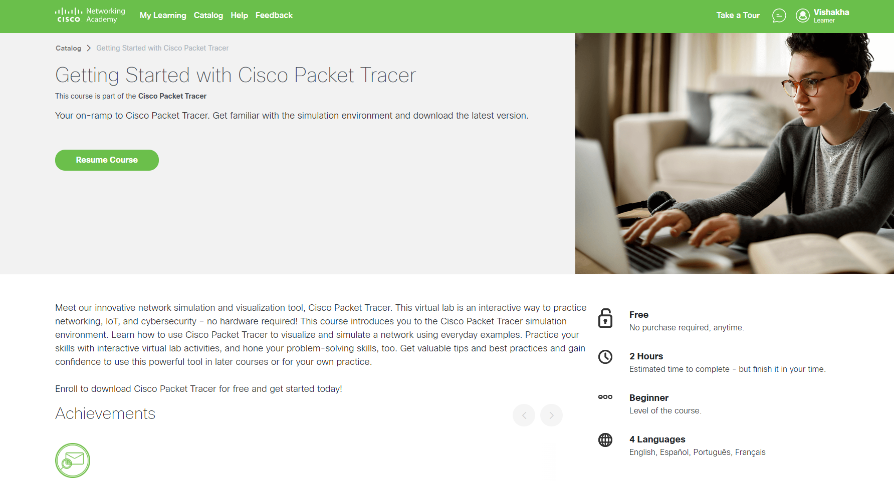

***Step 10 –***

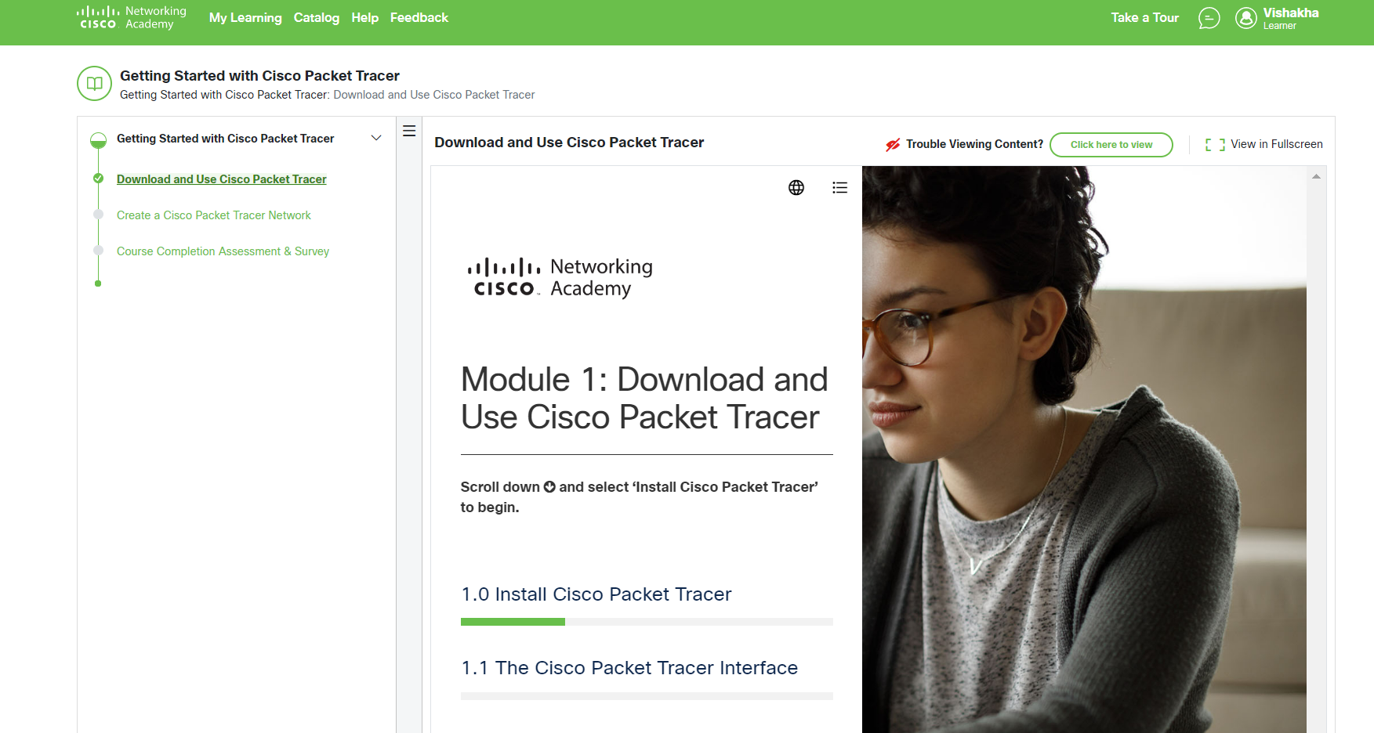

***Step 11 –***

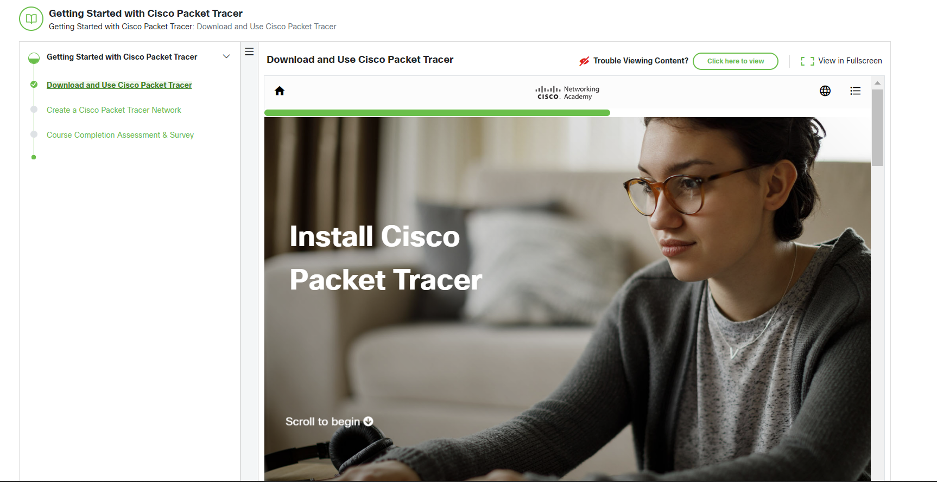

***Step 12 –***

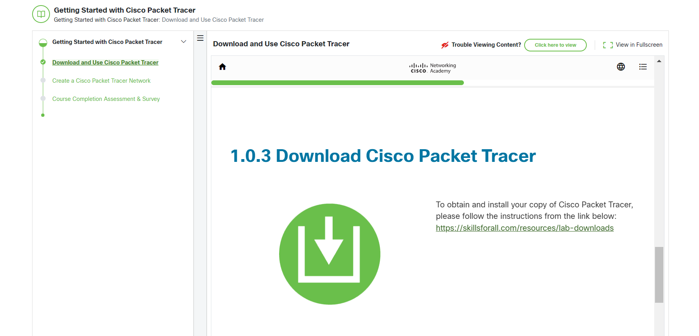

***Step 13 –***

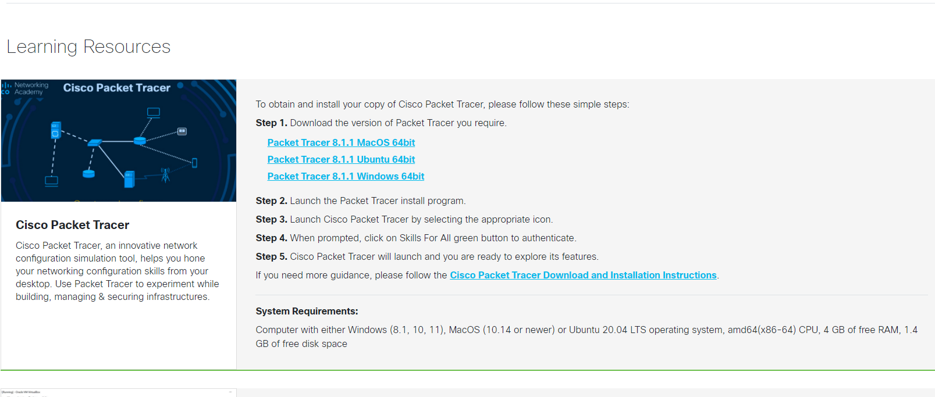

***Step 14 –***

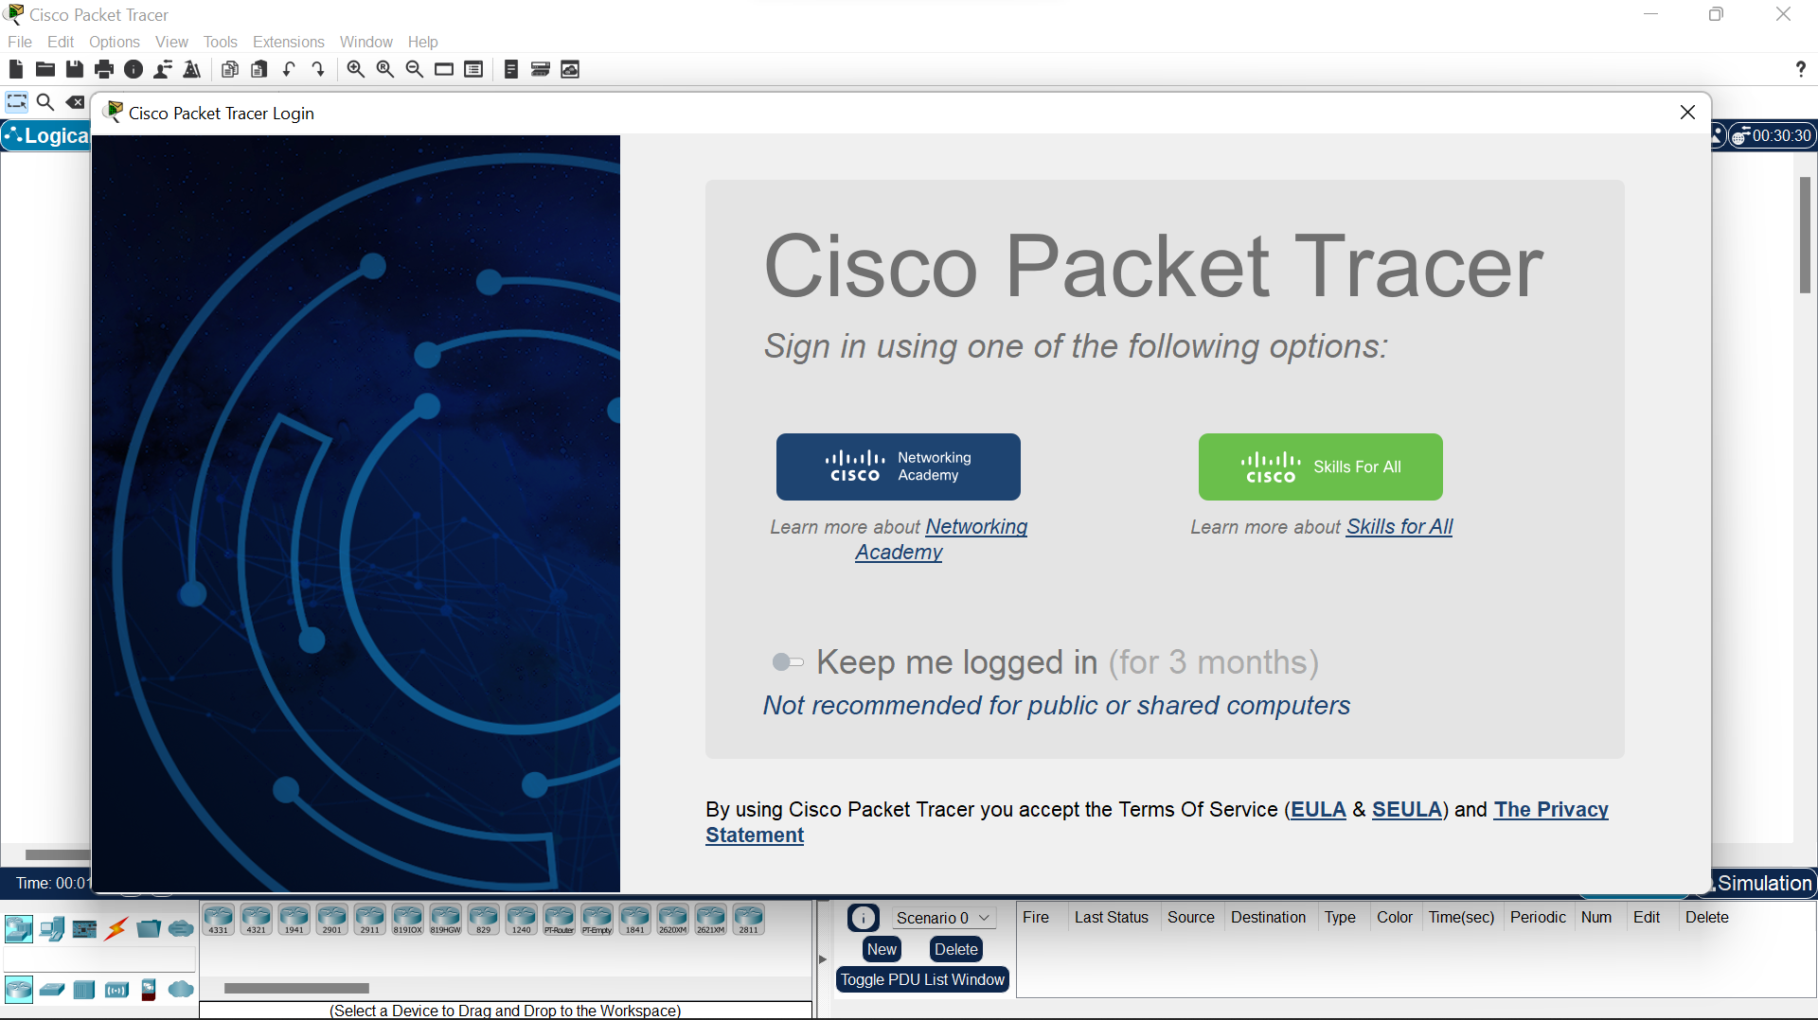

***Step 15 –***

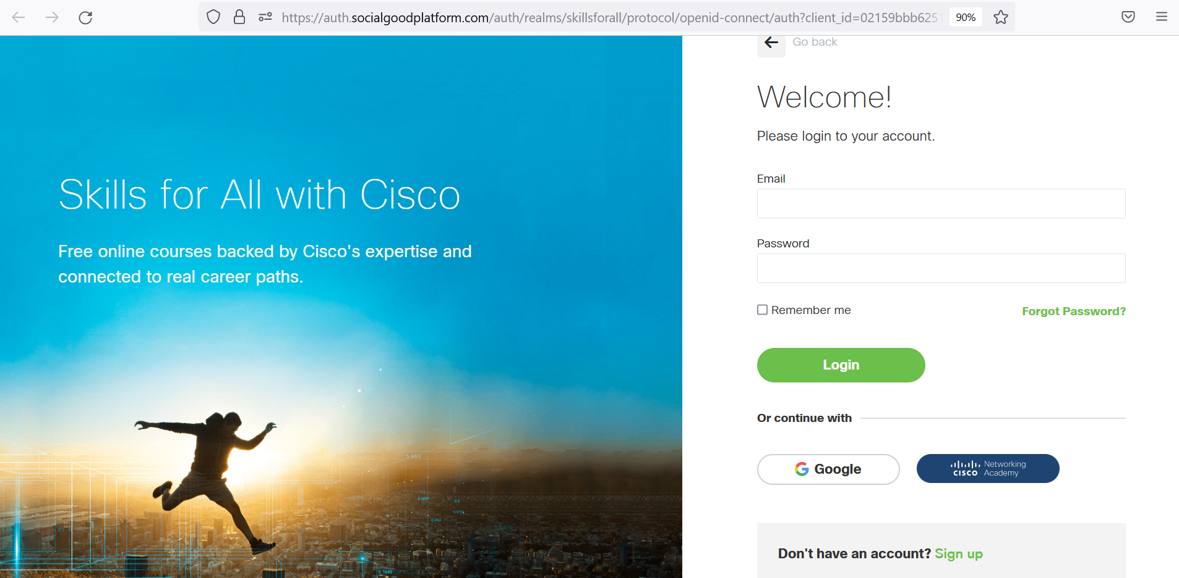

***Step 16 –***

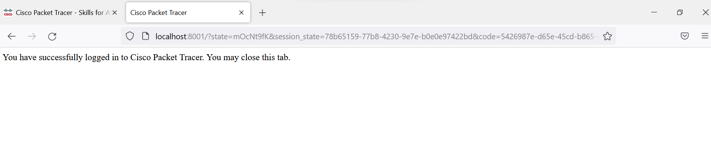

**ASSIGNMENT – 02**

**Establish pair to pair communication and show that delivery of packets is successful check MAC and PHY address of systems.**

**Solution:**

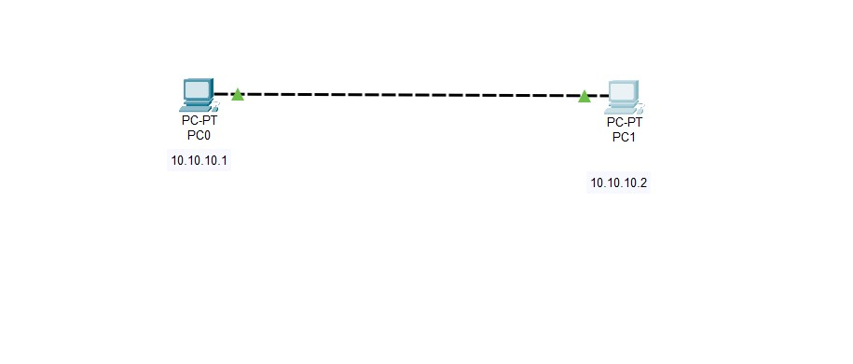

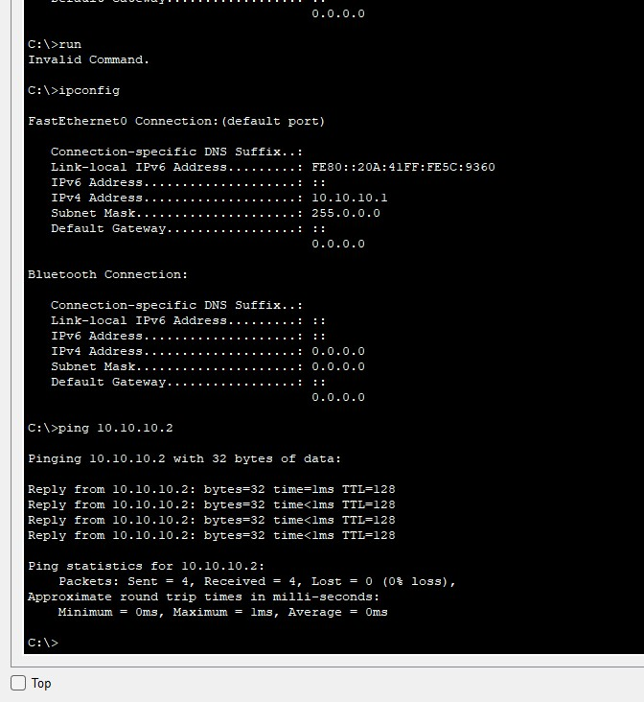

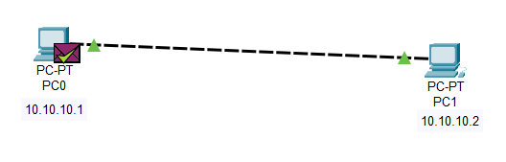

**ASSIGNMENT – 03**

**Simulate LAN using HUB after setting show packet movement through simulation.**

**Solution:**

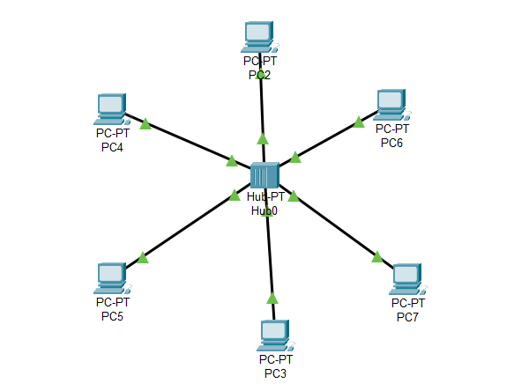

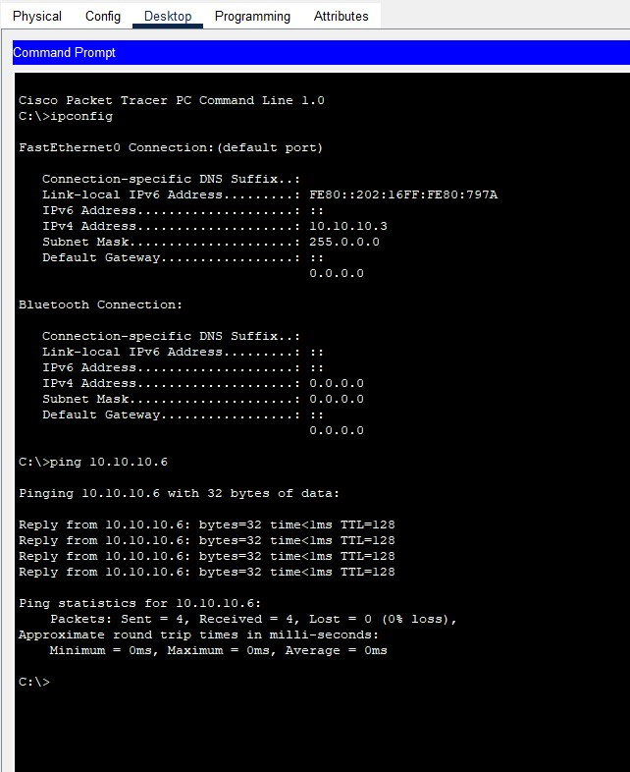

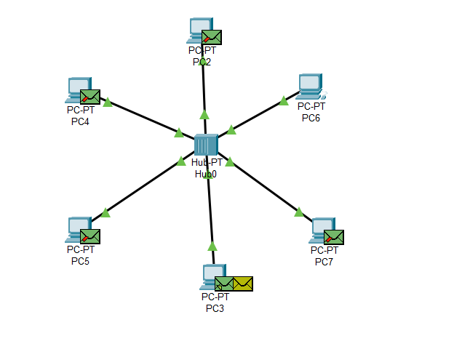

**ASSIGNMENT – 04**

**Question: Demonstrate the use of the switch and show through stimulation the working of the same.**

**Solution:**

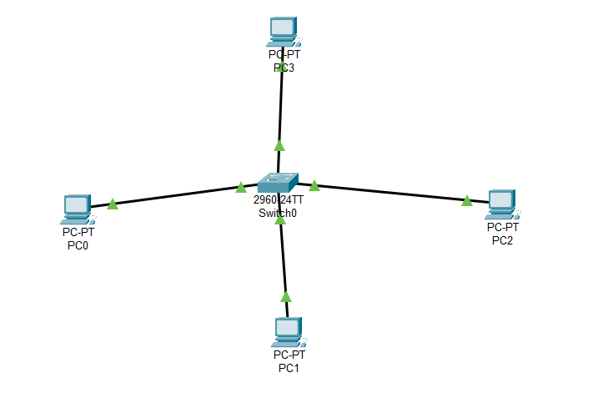

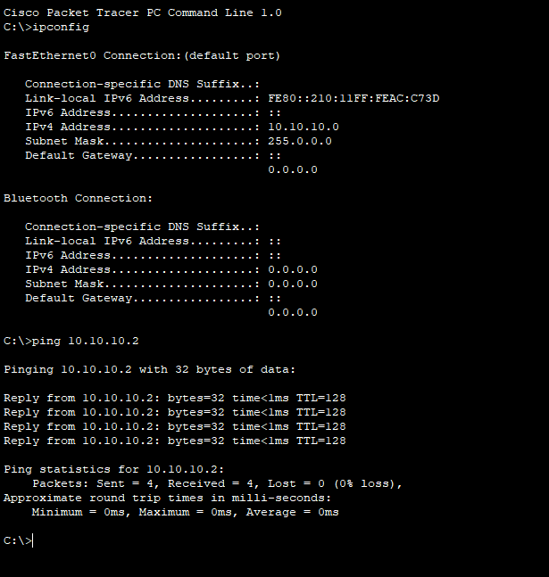

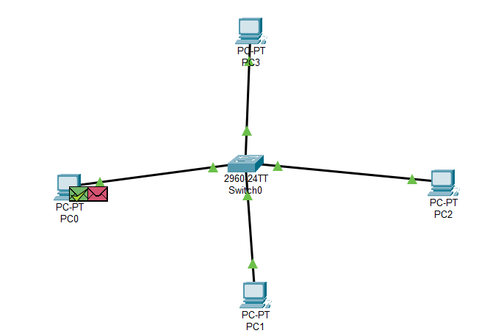

**ASSIGNMENT – 05**

**Question: Demonstrate static routing with the use of the router to establish communication between two different LANs.**

**Solution:**

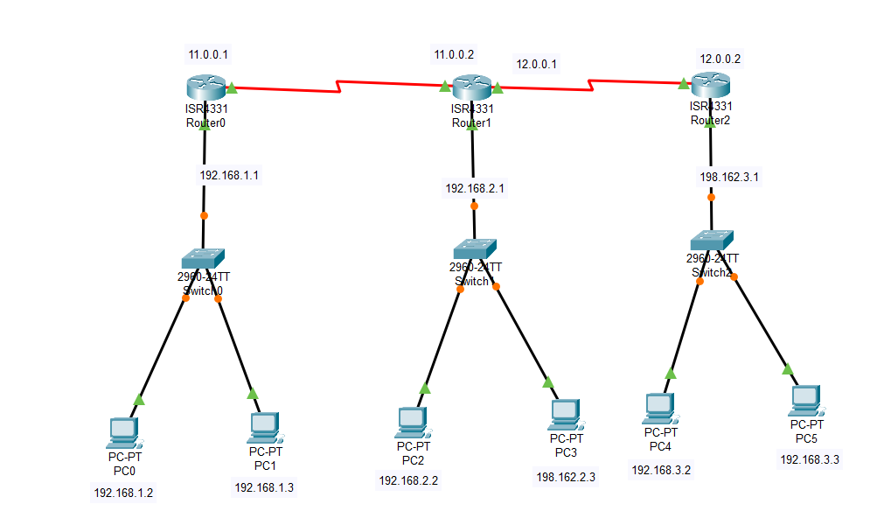

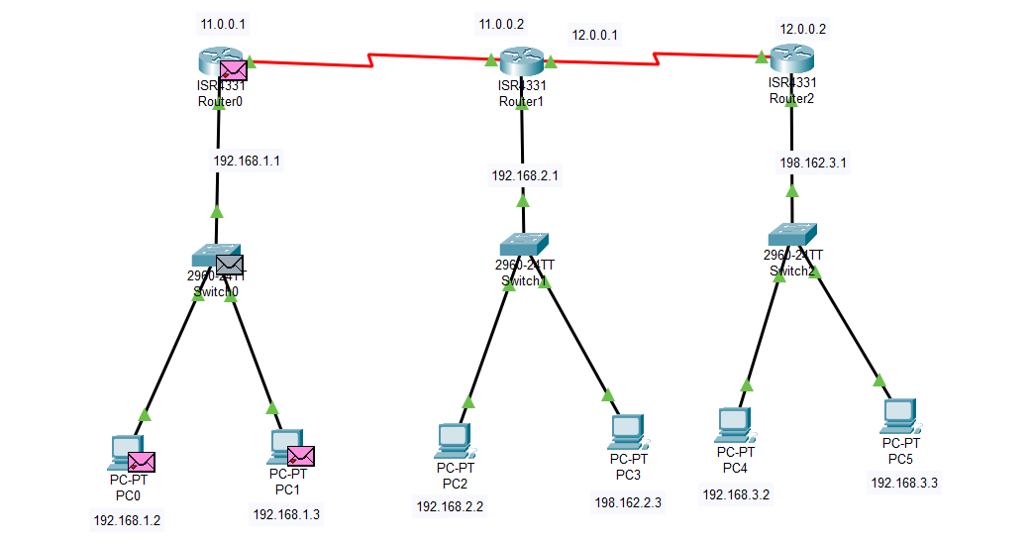



**ASSIGNMENT – 06**

**Question: Demonstrate Dynamic routing with the use of the router to establish communication between two different LANs.**

**Solution:**

